

# Accessibility Guide for Kendal Museum

[info@kendalmuseum.org.uk](mailto:info@kendalmuseum.org.uk), [01539815597,](tel:01539815597) <https://kendalmuseum.org.uk/>

**Contact for accessibility enquiries: Michael Bult**

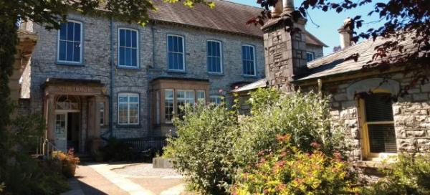

### Welcome

Kendal Museum was founded in 1796, making it one of Britain’s oldest museums. The Museum boasts unique collections of natural history, geology and archaeology, has a shop, cafe and play area, and hosts group visits, events and workshops.

## At a Glance

### Level Access

* The main entrance has level access with a ramp. The ramp is permanent.
* There is level access from the main entrance to:
  + Museum Garden

### Access with steps

* There are steps from the main entrance to:
  + Front Reception
  + The People's Gallery(Art Gallery)

### General

* We have a complimentary ticket policy for personal assistants.
* There is at least 1 public toilet for disabled visitors.

## Getting here

Station Road  
Kendal  
LA9 6BT

#### Travel by public transport

* You can get to Kendal Museum by bus and train.
* The nearest bus stop is on the Station Road, opposite to the museum entrance. There is also Kendal Bus Station on Blackhall Road, approximately 5 minutes walk to the museum. The bus stop is 0.0 miles / 0.0 km from Kendal Museum.
* The nearest train station is Kendal Station. The train station is 0 miles / 0.0 km from Kendal Museum.
* The Kendal train station is right opposite to the museum, across the road.

#### Travel by taxi

* You can get a taxi with KCarsTaxis by calling 01539731000. The taxi company has a wheelchair accessible vehicle.

#### Parking

* We have a car park. There are accessible parking spaces. The parking is less than 50 metres from the main entrance. Parking is not free.
* There is the museum car park near the main entrance of the museum which can be used as the nearest drop-off point. From the car park to the entrance, there is level access. There is a permanent ramp.
* The car park charge is £2 for 3 hours / £5 for all day.

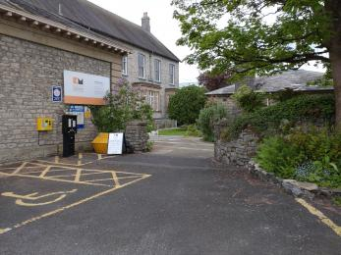  
View from the car park towards the museum

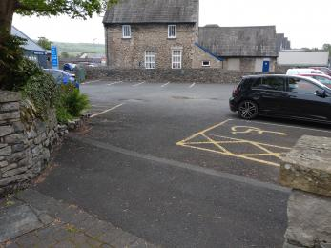  
The museum car park

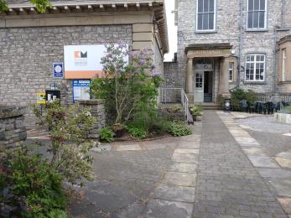  
Route from the car park to the museum entrances

## Arrival

#### Path to main entrance

* From the street to the main entrance, there is level access.
* There is a permanent ramp.
* The path is 900mm wide, or more.

#### Main entrance

* The main entrance has level access.
* There is a permanent ramp.
* The door is 1380mm wide.
* The main door is side hung and manual.
* The main entrance has 6 steps in total, but there is a side entrance with permanent ramp access. The visitors can enter from the side entrance as necessary and access the main reception. The side entrance can only be opened from inside by a member of staff. There is a bell for the visitors to let the staff know of their arrival.

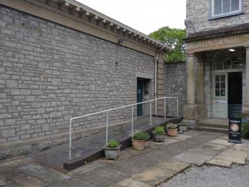  
Side entrance to the museum

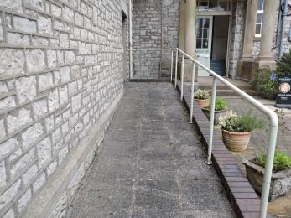  
Access to the side entrance

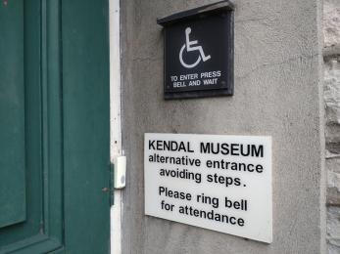  
The bell on the side entrance

## Getting around inside

#### Ticket/ information desk

#### Front Reception

* From the main entrance to this desk, there are 4 steps. There is no lift and no ramp.
* There is a side entrance to avoid any steps to the main reception.

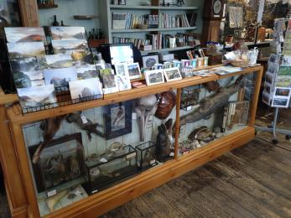  
Front reception

#### Things to See and Do

* We have a complimentary ticket policy for personal assistants.

#### Westmorland Gallery

* Some display information is low, for wheelchair users. There are seats.

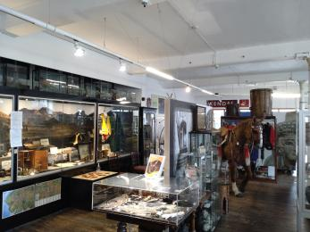  
Westmorland Gallery

#### World Wildlife Gallery

* Some display information is low, for wheelchair users. There are seats.

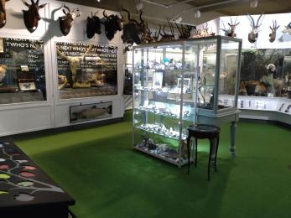  
World Wildlife Gallery

#### Public toilet

#### Museum Toilet

* There is a public toilet for disabled visitors.
* Both galleries and the public toilet are all on the same floor level.

#### Shop

#### Museum Shop

* The route through the shop is 800mm wide, or more.

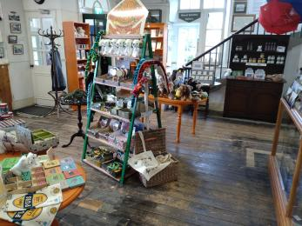  
Shop Area

#### Cafe area

* We serve quality coffee, tea and some cold drinks in cafe area. There are 4 sets of tables and chairs.

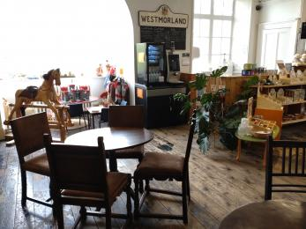  
Cafe area

#### The People's Gallery(Art Gallery)

* From the main entrance to this area, there are 18 steps. There is no lift and no ramp.
* There are a staircase of 14 steps and 4 additional steps to access the People's Gallery. We however can prearrange an alternative access via Kendal College entrance by a ramp access. Please ring the Museum front of house between 9:30-16:30, Thursday to Saturday.

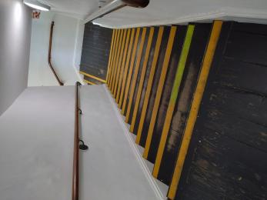  
14 steps to the gallery

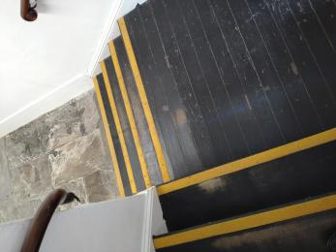  
Additional 4 steps to the gallery

## Getting around outside

#### Museum Garden

* From the main entrance to the gardens, there is level access.
* There is a permanent ramp.
* The route is 900mm wide, or more.
* From the main entrance to the gardens, there are 2 steps. There is no lift and no ramp.
* The route is sloped.

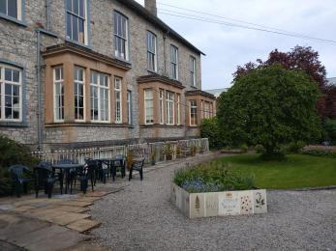  
Museum Garden 1

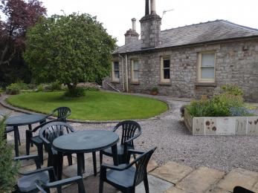  
Museum Garden 2

## Customer care support

#### Accessibility equipment

* The nearest toilet area for assistance dogs is located within the front garden, a couple of metres from the main entrance.

#### Emergency evacuation procedures

* We have emergency evacuation procedures for disabled visitors.

Guide last updated: 8 June 2023